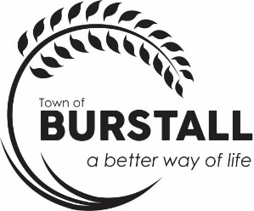
AGENDA
TOWN OF BURSTALL REGULAR COUNCIL MEETING Monday, December 15th, 2025, 6:30 p.m.

The regular meeting of the Council for the Town of Burstall will be held on Monday, December 15th, 2025, in the Council Chambers at the Town of Burstall Office commencing at 6:30 p.m.

- Call to Order

- Minutes
  - Regular Council Meeting November 24th, 2025

- Business Arising from the Minutes

- Statement of Financial Activity – November

- Delegate
  - 6:45 p.m. – Darwin Nowokowski from Triways – Transition to SK Recycle
  - 7:00 p.m. – Lucein Stuebing - questions
  - 7:15 p.m. – Larry Constable - questions
  - 7:30 p.m. – Owen Wittig – Town Foreman report

- Accounts for Approval - November

- Correspondence

- Reports
  - Mayor/Councillor Report

- Old Business
  - Eastview St. Survey Quotes Back Alley
  - Material Site Lease request
  - Lagoon signs
  - Sidewalk Inspection update

- New Business
  - Declaration Municipal Revenue Sharing Grant
  - Mayor and CAO authorized to sign Contract for Assistant CAO
  - Snow Removal Policy
  - SGI Document – Inspection Recommendations
  - Landfill Schedule 2026

- In Camera request – Motion to go into in camera under the Local Authority Freedom and Protection of Privacy Act, section 16 (1) (2) subsection (c) plans for the purpose of contractual negotiations by the local authority.

- Revisions to Council Procedure Bylaw 2021-195
- Bylaw to establish a revised Code of Ethics
- Contract Extension with Prairie Rising
- Next Meeting – January 27, 2026, 6:30 p.m.

- Recap of meeting/ Around the Table

- Adjourn

