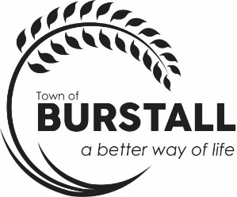
AGENDA
TOWN OF BURSTALL REGULAR COUNCIL MEETING Monday, November 24th, 2025, 6:30 p.m.

The regular meeting of the Council for the Town of Burstall will be held on Monday, November 24th, 2025, in the Council Chambers at the Town of Burstall Office commencing at 6:30 p.m.

- Call to Order

- Minutes
  - Regular Council Meeting October 14th, 2025

- Business Arising from the Minutes

- Statement of Financial Activity – Sept/October

- Delegate
  - 6:45 p.m. – Karen Dieterle - library
  - 7:00 p.m. – Liz McSweyn –
  - 7:15 p.m. – Lucein Stuebing
  - 7:30 p.m. – Gary Mathers – contract prairie rising
  - 7:45 p.m. – Owen Wittig – Town Foreman report
  - 8:00 p.m. – RCMP Constable Stephen Spence

- Accounts for Approval

- Correspondence
Triways – Transition to SK Recycle
Burstall Lions Christmas Tree request
Rec Board Request

- Reports
  - Mayor/Councillor Report

- Old Business
  - CAO Report on residency of a Councilor
  - December 2024 Financial Statements
  - Nuisance Abatement Bylaw 2006-100
  - Groundwater samples at Landfill

- New Business
  - Discretionary approval for a seacan
  - Helen Caywood – review of time as volunteer assistant
  - Library request – Karen Dieterle
  - Cost of surveying Eastview St. back alley

- EnCamera request – Motion to go into en camera under the Local Authority Freedom and Protection of Privacy Act, section 16 (1) (2) to discuss advice and proposals developed by and for the local authority, and subsection (c) plans for the purpose of contractual negotiations by the local authority, and subsection (d) plans relating to the management of personnel that have not yet been implemented.

- Designation of officer for complaint investigation
- Bylaw to Establish a Public Conduct Bylaw
- Next Meeting –December 22, 2025, 6:30 p.m.

- Recap of meeting/ Around the Table

- Adjourn

