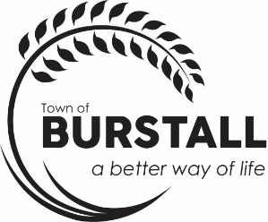
AGENDA
TOWN OF BURSTALL REGULAR COUNCIL MEETING THURSDAY, October 14th, 2025, 6:30 p.m.

The regular meeting of the Council for the Town of Burstall will be held on the Tuesday, October 14th, 2025, in the Council Chambers at the Town of Burstall Office commencing at 6:30 p.m.

- Call to Order

- Minutes
  - Regular Council Meeting August 14th , 2025, the Special Council Meeting August 17th and the Special Council Meeting September 17th

- Business Arising from the Minutes

- Statement of Financial Activity – August

- Delegate
  - 6:50 p.m. – E. McSweyn Residency Question
  - 7:00 p.m. – H. Jansma Strategic Planning
  - 7:10 p.m. – L. Constable speed sign, sewer lines, town funds sidewalks, storage
  - 7:20 p.m. -G. Mathers question on prairie rising contract
  - 7:30 p.m. Owen Wittig - Town Foreman Report

- Accounts for Approval

- Correspondence
Burstall Recreation board
Chinook Regional Library
Community Building Fund 2025-26
Brad Dieterle

- Reports
  - Mayor/Councillor Report

- Old Business
  - Appoint Tim Marcus as CAO and Jim Puffalt as Associate CAO
  - Requests re: town filling holes in back alleys
  - Groundwater Monitoring (landfill) Pinter & Assoc. quote $9830.00

- New Business
  - Sign Quote
  - Line lagoon with rocks/concrete
  - Prosperity Credit Union term due, monies in savings

- EnCamera request - Personnel Matter
- Designation of officer for complaint investigation

Next Meeting –November 24, 2025, 6:30 p.m.

- Recap of meeting/ Around the Table

- Adjourn

